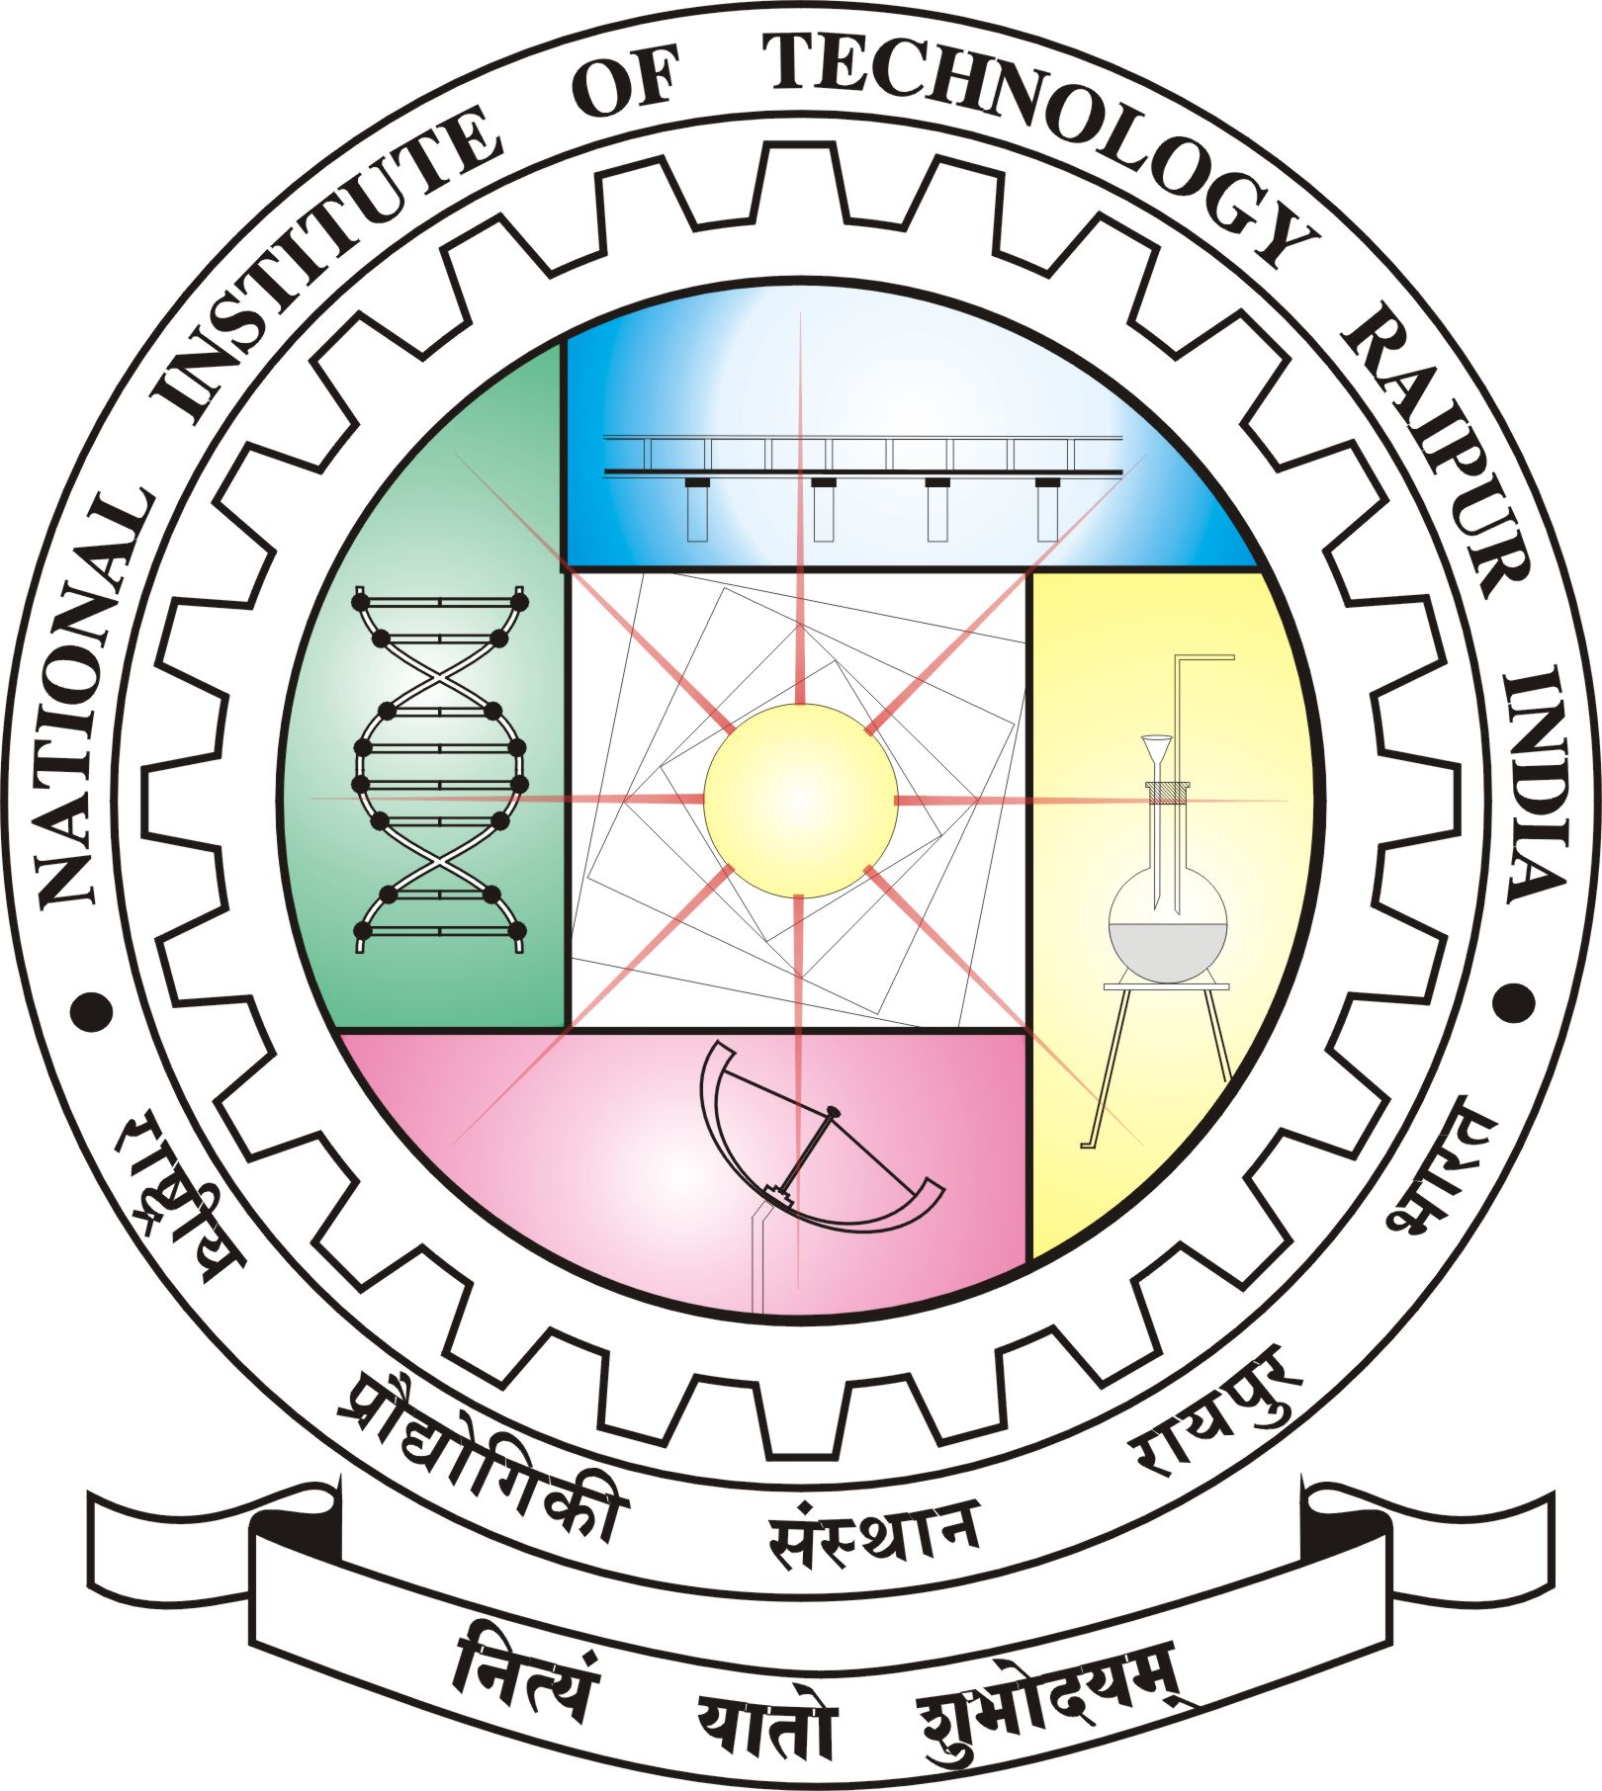
NATIONAL INSTITUTE OF TECHNOLOGY RAIPUR
CENTRAL LIBRARY
G.E. Road, Raipur - 492010 (C.G.)
Phone No. (0771) 2254200 Fax No. (0771-2254600)
Website: www.nitrr.ac.in
Application Form for the post of Library Trainee
Post applied for | Library Trainee  Paste Self attested Photograph
Name in Block Letter
Date of Birth
Permanent Address
Present Address
E-mail ID
Mobile
Educational Qualification (Form 10th onward)
SN | Name of the Exam passed | University /Board | Year of Passing | Division/Class
1
2
3
4
5
6
Experience :
Any other relevant information:
Declaration: I hereby declare that the information furnished above are true to the best of my knowledge and my candidature may be cancelled at time if found any discrepancy.

Place & Date Signature of the Applicant

